Tones of Summer

Identifying the tone of a piece of writing is one of the most important skills students need in AP Literature. Below is a list of commonly found tones in literature. For EACH of the tone words below find an example of that tone and explain how your example demonstrates that tone. You may find your examples in a variety of ways: books, poems, song lyrics, social media sites, video clips, advertisements, TV show clips, movie clips, comic strips, billboards, political speech clips, photos, memes, games, etc. **A minimum of 10 tone words must be text-based examples.**

Once you have your examples, create a PowerPoint with a slide for each “tone” word. On each slide include the following: tone word, part of speech & definition, example, and explanation. For slides including text-based examples, include the title of the literary work and the page number in addition to the above-listed information.

**Tone Words:**

Absurd affable anxious

Condescending Dignified disgruntled

Disillusioned Disparaging eager

Empathetic Exuberant Frustrated

Gloomy Grave Haughty

Incredulous Indifferent Indignant

Jovial Joyous Lighthearted

Melancholic Melodramatic Optimistic

Pompous Pragmatic Remorseful

Resentful Reverent Sarcastic

Satirical Sinister Somber

Startled Whimsical Witty

Example:

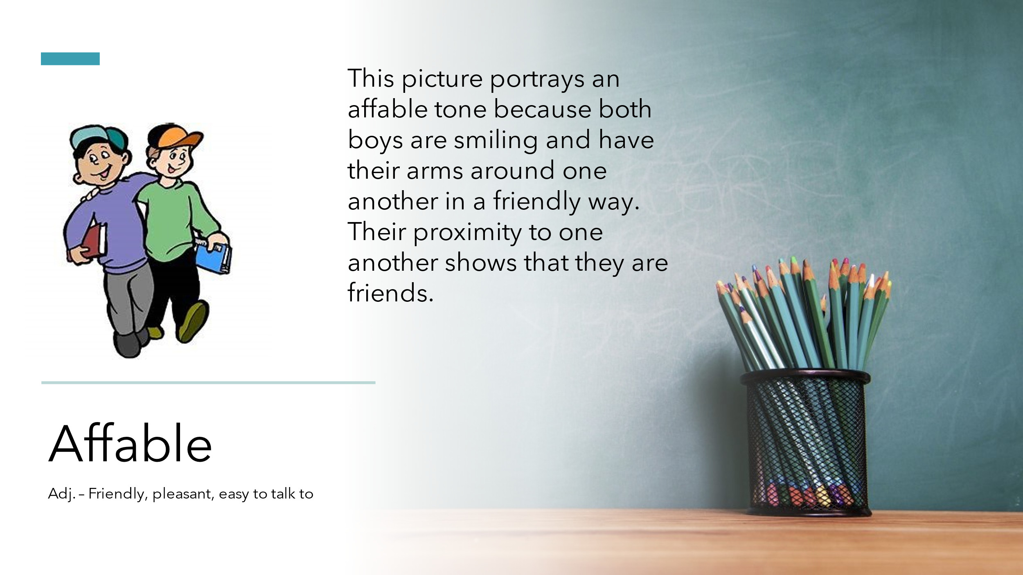

**This assignment will be due on the third day of school in August.**

**Be prepared to present one or two of your favorite tone examples to the class.**